Promoting Second Language Learning through a Peaceful Education: An Internship Journey Applying Gamification and Task-Based Learning

Internship Final Report

Yaireth Cabrales Rojas

Advisor
Martha Elvira Paz

University of Córdoba
Bachelor in Languages with an Emphasis on English

Monteria, Colombia
2024


_________________________________________________________________
ADVISOR



__________________________________________________________________
JUDGE



__________________________________________________________________
INTERNSHIP COORDINATOR

Abstract
This paper details my internship experience through the Bilingualism for peace program at La Rivera school. Specifically, with students from 8 to 13 years old belonging to Beginners and pre-intermediate levels. The main purpose of this academic journey was to apply gamification and task-based learning to enhance student’s communicative skill, as well as promoting a peaceful environment through the language. Regarding gamification, it was a powerful tool that supported the process of improving student’s communicative skill, and the task-based learning approach helped provide meaningful tasks focused on students’ needs and context. Additionally, through this internship, students were able to experience a diverse and enjoyable educational space.
Key words: internship, bilingualism for peace, gamification, task-based learning, communicative skills.

Table of content
1. Introduction...................................................................................................................5
2. Underlying Theories…..................................................................................................8
2.1. Gamification......................................................................................................8
2.1.1. Gamification in Educational Context.............................................................10
2.1.2. Motivation as Primary Outcome of Gamification..........................................12
2.2. Task-Based Learning (TBL)..............................................................................13
3. Teaching Methods and Strategies ................................................................................16
3.1 Duties Chart.........................................................................................................19
4. Gains............................................................................................................................23
4.1. Duties Chart.......................................................................................................27
5. Conclusions................................................................................................................29
6. Limitations.................................................................................................................33
7. References..................................................................................................................34
8. Appendix....................................................................................................................37

Introduction
Throughout the years, Colombian Education has recognized the need and importance of learning a new language, specifically English. Thus, the Ministry of Education (M.E.N.) has created many bilingualism programs to ensure education with a new world vision and one based on new ways of expression and ideas promoting values and principles. As reported by Mejía (2006), The idea is that this recognition of linguistic and cultural diversity in our world may lead to recognition of the importance of tolerance and respect for the other. Hence, it can be said that English as a second language is challenging for Colombian students since it provides a different foresight of their educational context.
In response to these needs in the Colombian educational context, the University of Córdoba has created a program in the department's capital Monteria called Bilingualism for Peace. This extension seeks to provide basic language learning in different areas of Monteria, considering all the city's cardinal points. It also addresses social problems such as inequity among the population, in specific, accessibility to learning English through a course apart from the school itself. Particularly, the purpose of this internship was to promote and engage students in second language learning applying a mixture of approaches and methods aiming to not only acquire knowledge but also enjoy the experience of a new culture through the language.
This internship was carried out via this program in the public institution La Ribera located east of the city, in the urban area with stratum 2. Its educational space consists of two floors and a courtyard lounge located in the center of the school; the classrooms have a board, a desk, and student chairs in good condition. Regarding teaching resources, it is available on video beam and computer room for all the teachers, nevertheless, it does not hinder class development. It is a school recognized within the program due to students' and parents’ dedication to the program, which facilitates the learning process.
Different approaches and methods were implemented during this internship to achieve the goals mentioned before. At first sight, students were not interested in sharing their ideas and opinions with the class since they do not feel confident speaking another language, therefore through the classes, it was carried out an approach called gamification with the aim of incentive the students to be involved not only with the class but with their classmates and teacher, in general, the games were focused on enhance communicative students’ skill. As stated by Dichev and Dicheva (2017), Gamification of education is a developing approach for increasing learners’ motivation and engagement by incorporating game design elements in educational environments. These games were applied using different resources in the classroom such as speakers, flashcards, balloons, video beams, and others.
To enhance students’ English skills another approach implemented was Task-Based Learning (TBL). Since the main purpose of the classes was that students were the center of the learning process and develop their communicative skills, this approach is a powerful tool that gives interactive and meaningful tasks providing a communicative and collaborative environment between students. For instance, creating posters, producing flashcards, and handcrafts are some of the activities that were developed using this approach.
All along, the main purpose of this internship was to implement gamification and task-based learning to enhance students' communicative skills. As well as, promoting a safe environment through a peaceful and unbiased education. Through different chapters, this paper analyses various aspects of my internship. Chapter I: Introduction, Chapter II: Underlying Theories, Chapter III: Teaching Methods and Strategies, Chapter IV: Gains, Chapter V: Conclusions and Suggestions, Chapter VI: Limitations.

Underlying Theories
It is not a secret that teaching a second language is a challenge for English teachers since many students in the classroom do not feel engaged in the learning process because it is not their native language, they feel anxiety when speaking another language, or they do not have self-confidence. Hence, some of the primary elements that cannot be missed in an English class are patience, creativity, and flexibility in the activities. To fulfill these expectations in the classroom, it is crucial to implement a mixture of approaches taking into account students’ context and needs. The approaches that will be examined in this paper are Gamification, and Task-Based Learning (TBL)
2.1. Gamification
Over the years, the term gamification has been widely recognized in diverse fields of life such as education, technology, or culture. This concept has been defined in many ways; for instance, “the phenomenon of creating gameful experiences” (Hamari et. al., 2014), and “the process of making activities more game-like” (Werbach, 2014). Furthermore, “gamification is defined as an intentional process of transforming any activity, system, service, product, or organizational structure into one which affords positive experiences, skills, and practices similar to those afforded by games, and is often referred to as the gameful experience” (Hamari, 2019, p. 1). Despite gamification being a new concept, it has made room in the world in different aspects because through this term it recognized the importance of maintaining motivation and fun in daily life activities such as education, work, healthcare, etc.
Gamification’s acknowledgment in different fields is based on the transformation of some attitudes in people. As reported by Dichev and Dicheva (2017, p. 1) “The growing popularity of gamification is stemming from the belief in its potential to foster motivation, behavioral changes, friendly competition and collaboration in different contexts, such as customer engagement, employee performance, and social loyalty.” Thus, gamification becomes the different environments in which individuals' potential is developed, focusing on maintaining a pleasant, appropriate, and enjoyable place.
Moreover, as it was mentioned before, gamification applies in different contexts, however, it is important to take into account the public in which the activities are focused. Gamification design targets various audiences and activities and attends to diverse motivational needs that individuals may have in varying gamified contexts (Koivisto & Hamari, 2019). Therefore, to implement gamification in a context it is crucial to bear in mind the individual’s context and needs, in that way, it is more likely the success of the activities.
In specific, a crucial section in which gamification has gained recognition is education. It has been proven through different research papers that gamified context tends to improve not only an individual’s behavior in class but also a better understanding of the activities.

2.1.1. Gamification in Educational Contexts
As Knowledge is the most powerful tool that a human being can have, education should be an enjoyable and meaningful experience.
Learning through games has demonstrated many advantages in the classroom, which is why it is been implemented nowadays in many educational areas. According to Dichev and Dicheva (2017, p. 2), “Gamification in education refers to the introduction of game design elements and gameful experiences in the design of learning processes.” “In the context of education, the integration of gaming elements into learning experiences—known as gamified learning—is particularly notable for its array of associated benefits” (Lee & Baek, 2023, p. 2). Later, Chans and Lo (2024) reported that gamification is a pedagogical strategy that can be delineated as the application of game design elements and gaming principles within educational contexts.
Particularly, gamification has been explored in the context of learning a new language, specifically English. Lee and Baek (2023) stated that in EFL, gamification entails the use of game design principles and elements, such as rewards, badges, leaderboards, and challenges, aiming to motivate learners, augment their engagement, and render the learning process more enjoyable. Moreover, Chan and Lo (2024) stated that in the landscape of English language education, the integration of gamification has marked a transformative trend by influencing learners’ attitudes emotional engagement positively, and fostering an immersive language learning milieu.
Gamification has made room for second language acquisition by implementing different techniques and approaches based on games and focusing the attention on students’ learning. “The use of Gamification in educational settings toward L2 learning involves pedagogical approaches, methodologies, and strategies.” (Figueroa, 2015, p. 33). This means that gamification does not work alone, but needs adjustment to the different teaching strategies implemented in the classroom taking into account what most fits the learners. Kapp (2012) states that gamifying activities are a way to incorporate game-based learning strategies into the classroom, and provide learners with “the sense of engagement, immediate feedback, feeling of accomplishment, and success of striving against a challenge and overcoming it” (Cited in Boudadi & Colón, 2020).
Gamification is a powerful tool that can be used in the teaching process; however, it is crucial to know how to implement it to accomplish a goal in the educational context. Chan and Lo reported that gamification constitutes a cutting-edge trend in the landscape of contemporary English in many educational settings including English as a Foreign Language (EFL) and English as a Second Language (ESL). Therefore, gamification seeks to leave those conventional ways of learning English in which students read, listen, and write. Instead, this concept proposes strategies that create a connection between students and their learning process enhancing the learners’ motivation to acquire a second language. According to Chan and Lo (2024, p. 2), “Recent studies have validated the potential of gamification to improve student motivation, engagement, and interaction in education while allowing them to immerse themselves in experiential learning”. That is why, integrating games into the process of learning a new language leads to a change in student’s behavior, which ends up creating a positive learning experience.
2.1.2. Motivation as the primary outcome of gamification
Motivation is the process that induces, directs, and sustains behavior toward a goal; determining this concept is the level of expectation to prepare, learn, and achieve a goal. As stated by Dichev and Diveva (2017) motivation is seen as a psychological process that gives behavior purpose and direction is contextual. Not only are individuals motivated in multiple ways, but also their motivation varies according to the situation or context of the task. “Motivation has proved to be one of the determining factors in learning a foreign or second language successfully” (Gardner and Lambert, 1972, as cited in Listyani, & Tananuraksakul, 2019, p. 55). Motivation is among the most important aspects of student academic achievements, which influences the effort and time a student spends engaged in learning (Linehan, et. al., 2011, mentioned in Dichev & Dicheva, 2017). Thus, motivation plays an essential role in students which carries out an area that can impact students' performance in second language learning.
Keeping students’ motivation in class is not an easy task, that is why gamification plays an essential role in the learning process. Brown (1994) sees motivation as a necessary personality factor that learners need to acquire a second language. (cited in Figueroa, 2015). Therefore, educators often look for ways to maintain student’s motivation given its importance in L2. Boudadi and Colón (2020) noted that gamification is often used exactly to stimulate behavioral aspects like motivation and engagement. Many research papers have stated that gamification constantly promotes students’ motivation by implementing activities focused on their needs and context.
Further, the influence of gamification on students’ motivation, satisfaction, empowerment, and achievement scores is complex and context-dependent. (Chan & Lo, 2024). In addition, motivation increases in a gamified instructional environment when the learner's performance is publicly recognized through a reward system of prizes/awards. (Figueroa, 2015). It means that students feel motivated in class with challenging activities such as collaborative competitions. According to Boudadi and Colón (2020), Gamification also creates dynamic environments in which people can feel a sense of progress by achieving levels. Then, it can be said that a gamified context offers a variety of activities such as Role-playing scenarios, a level-up progression system, quiz battles, badges for achievements, and so forth.
2.2 Task-Based Language Learning
Learning a new language leads to a unique experience surrounded by authentic tasks.
Task-based language learning (TBLL) is an approach centered on meaningful tasks in which students enhance their English skills promoting participation and a collaborative environment in class. Task-based language teaching, also labeled as task-based language learning and task-based instruction, constitutes an approach to language teaching and learning that prioritizes the use of authentic language to complete meaningful tasks in the target language (Qin & Lei, 2022). This approach promotes students’ communicative skills by implementing interactive tasks through different phases.
TBI is an approach that employs a variety of interactive tasks to engage learners in meaningful communication to achieve communicative purposes, which increases interest in the language and become the most fashionable pedagogical approach among foreign language teachers in the past few years (Oxford, 2006; Santos, 2011, cited in Nget et. al., 2020). Moreover, this teaching strategy provides a variety of tasks with the purpose of incentive students speaking skills. “The primary goal of a communicative task is to promote meaningful communication and interaction among learners. In addition to focusing on meaning, a communicative task should also have a sense of completeness.” (Li, 2023, p. 191).
Thus, it is important to know what kind of task is useful when implementing this approach, since the main purpose is to provide learners with rich language through effective communication. When implementing tasks, different interactive methods are adopted by teachers and students, such as paired or group discussions, role-playing, and debates, to push the process of completing the assignment (Li, 2023). As stated by Lu (2024), through this approach students are encouraged to process, integrate, and apply information during task completion, promoting language skill development and deepening their understanding and application capabilities of the language. All along, TBLT has been an interesting approach that engages students in real-life scenarios leading to a significant experience using a foreign language.

Teaching Methods and Strategies
Through a mix of teaching strategies and methods, meaningful learning is achieved.
During this internship, the main objective was to apply gamification and task-based language learning to improve students’ communicative skills in second-language acquisition. Along with this strategy, students not only acquire knowledge but also enjoy the experience of a new culture through the language. Thus, considering students’ needs and context, these two approaches were the backbone of this academic journey.
First, it is crucial to say that gamification become the main pedagogical strategy in this internship since it keeps students’ interest and motivation during the classes. Gamified activities help the lessons to run efficiently because they allow students to create scenarios in which they feel engaged with the language, providing not only a dynamic environment in the class but a positive behavior in learners. At the beginning of the classes, students show fear of participating in class, sharing their opinions, or simply the fact of speaking another language seemed terrifying to them. However, with the implementation of gamified activities, students felt more relaxed, changed their attitude and in the end had fun learning a new language.
Gamified activities such as role-playing scenarios, level-up progression systems, badges for achievements, leaderboards, and challenges were implemented with the learners using different topics. For instance, a healthy competition between groups was carried out in a lesson plan in which students needed to learn action verbs and apply themes in situated practice. There was a mixture of games in this competition, students performed actions, drew them on the board, and guessed the action according to some images, at the end the group with the most points won a benefit in the next written activity, in this way, students keep their attention during the activity and dynamically learn the topic.
Moreover, gamification was the best strategy to implement with these students because some of them had their first interaction with the language through this course, then sharing enjoyable time with their partners while learning knowledge was a great experience. After several classes, students changed their attitude by participating, promoting group work, asking questions, and sharing their game ideas for future lessons.
On the other hand, another teaching approach applied in this internship was task-based language learning, which consists of work with meaningful tasks that lead to authentic language. This pedagogical method allows the students to learn by heart the different topics since they had to work on various phases to accomplish the final goal of the task. To implement TBLL in the classroom, it was crucial to identify the preferences of the students; for example, they like to work in groups, oral presentations, interactive videos, and creating posters and handcrafts.
The main objective of this teaching approach was to enhance students’ communicative skills, which is why most of the tasks were based on pair conversations. To illustrate, students worked on a topic called shaping peace using language as a primary tool for effective communication; to develop this lesson, students classified positive and negative phrases that can be used in situations in their daily lives. After that, students get in pairs, choose one phrase from a box, use it in a conversation, present it, and create a comic strip (Table 1). The idea of this task was to connect students with a daily life situation and ask them to find a solution using the phrases learned during the class. In this way, students learn about conflict resolution through the construction of peace and acquire meaningful knowledge that can be used in their lives.
Moreover, it is important to remark that there were some difficulties while implementing these two teaching methods mentioned before. For instance, some students lose their attention quickly during the lessons because they do not understand the language, and feel blocked during the activities. Also, various learners got excited with the games which fostered indiscipline in class, and sometimes the activities had to stop because half of the classroom was not participating. After a while, students’ strengths and weaknesses were identified, in this way, it was easier to look for activities that suited their personality and identity.
Throughout this internship, these two teaching approaches (Gamification and Task-based learning) became the backbone of these academic experiences since not only the students but also the teacher felt engaged with the classes. Thus, the most important aspect that helped this project run efficiently was the implementation of different teaching strategies along with the educational community. This facilitated the learning of a new language for students who were interacting for the first time with a language that was partially unknown to them.
3.1. Duties Chart
Table 1
Lesson Plan Using Gamification and Task-based Learning Approaches
Task/Project/Problem | Learning Outcomes | Learning Teaching points
Students will present a comic strip recreating a conflict using positive and negative phrases learned in class. | - Identify positive and negative phrases.  - Recognize his/her responsibility in the construction of peace in his/her community.  - Recreate experiences using the present tense. | - Negative and positive words: anger, exclusion, empathy, cooperation.  - Adjectives to express emotions: scared, tired, sad, etc.  - Present tense
Warm-up | Resources/Materials | Time
The teacher will pass a balloon around the classroom, it cannot touch the floor, as each student touches the balloon, they must say a word in English related to emotions such as sad, scared, happy, etc. | Balloon | 15 minutes
Core Tasks
To introduce the topic, students will watch a short video presenting real-life examples illustrating the impact of positive and negative language on community interactions. Students will identify the emotions expressed by the people in the video.  Students will be divided into two teams. From each group, a classmate will have to act, mimic, or draw on the board the situation the Teacher whispered related to emotions, positive and negative phrases, etc. Students in Group 1 will have one minute to guess the answer, and Team 2 will stay silent until the time passes. If Team 1 does not give the correct answer, then Team 2 can participate to get the point.  The teacher will prepare in advance small cards with words written on them. Students will categorize the phrases into positive and negative, and discuss the impact of each word on community relationships. | Computer  Video Beam  https://youtu.be/UPCi91cvnmI?si=uhW27E3rV96QmmEX  Small cards  Group Work  Board  Small cards  Board  Adhesive Tape | 20 minutes  30 minutes  40 minutes
Closure
Students will get in pairs to create a comic strip, in which they will recreate a situation using a positive or negative phrase indicated by the teacher.  Students will present their comics as a conversation and explain the solution to the problem. | Positive and Negative Phrases Handouts  Colors, markers, and paper sheets  Presentation | 50 minutes  40 minutes

This lesson plan was the most remarkable class using both approaches, gamification, and Task-based language learning. Moreover, it combined two topics: Emotions (students saw this topic in their previous semesters), and Shaping peace through community language. During the implementation, students worked with different pedagogical resources which maintained their motivation in the class by sharing their ideas and discussing the topic. Besides, the task application was a successful activity because it had different stages of development. First, Students needed to choose a phrase, understand it, think about a situation where they could use it, and present their comic. Students paid close attention to fulfilling all of these stages, which reflected the success of the activity and their commitment to the class.

Gains
Considering the impact that the Bilingualism for Peace program has on the students, teachers, and all the educational community involved, this was a challenge for me because I felt a big responsibility to do a great job with the students and the entire project. Further, this was an experience that helped me develop my personal and professional skills as a teacher, then I saw this internship as a big opportunity to grow and decided to take advantage of it in every aspect. Therefore, I felt that I put in a lot of effort doing my administrative and academic work, not only to fulfill the initially set goals but also to create a nice memory of this academic initiative, which would also be my first direct connection with my future teaching work.
From the first sight, I marked the intention of carrying out unforgettable classes for my students, since this was the first time they would take English lessons through a university course. Hence, to begin the classes we developed a discussion activity to identify what the students wanted to learn during the course, some of them stated the desire to explore new cultures through the language, along with communicating with different people around the world and enhancing their English skills. Through this activity, I clarified that most of the students were excited and had a lot of expectations about the course, therefore I got involved with my students and their goals building dynamic, different, diverse, and exciting classes.
To begin the classes, I always tried to look for an interactive activity in which my students feel relaxed; for example, I gave them a balloon and they had to pass it between them without letting it fall to the ground, but they couldn't get up from the chairs when the balloon hits the ground, the class begins (Table 1). Applying these warm-up activities for my classes helped me connect with my students, and had a great time before we started the new topic, in this way, I realized that my students started the class excited, without laziness, and willing to learn. However, sometimes it was difficult to choose a good activity in which all the students participated, which is why I often repeated them with a small difference. To illustrate, In the balloon activity, I would add the variation that each student had to touch the balloon once, in this way, it became more fun and challenging for them.
As time went by, my students and I understood each other in a better way, which facilitated a lot the process of planning and choosing activities for a new topic. In specific, most of my students liked to use different materials for the classes including scissors, magazines, speakers, color markers, and so on; therefore, I focused on activities such as handcrafts, comics, and posters. These types of activities were completed, since I noticed that students felt concentrated, had fun, and it also encouraged collaborative work. Nevertheless, not everything was easy, sometimes I had to pay close attention to students who took advantage of this time and fostered indiscipline in the classroom. To prevent this behavior, I provided feedback at every step of the activity and walked around visiting each group, also I used the speaker and played enjoyable songs that relaxed the students while they worked on the task.
Further, I determined that some students had problems maintaining their attention for a long period, hence I decided to focus on short explanations and tried to involve body language to attract their attention. This strategy was a success since my students engaged more with the classes if they saw me walking, moving my body, and making funny faces. This was an important aspect to take into account, because in some classes I explained the topic and activity, and then students came and asked me what was the activity about. Then, I realized that I needed to slow down and verify that everyone was paying attention to avoid repeating the same explanation several times.
After implementing all these strategies, I noticed a change in behavior in students, they felt more motivated during the classes, paid attention to my instructions, enjoyed the lessons, and promoted a safe environment in the classroom. Hence, I believe that when we listen and observe our students, we can look for new tools that facilitate the process of learning, every concern or doubt that a student has is an opportunity to change and innovate your way of teaching. That is why, I learned not to get blocked when some classes do not go as planned, as that teaches me to be better every day and explore different approaches and methods of learning a second language.
On the other hand, my administrative activities with the program were based on keeping up with student grades, notifying parents of their academic status, organizing recreational activities, collecting paperwork on students, keeping my internship advisor updated on any mishaps, and keeping an eye on interns and their questions about the program. These responsibilities, along with the academic ones, became hard since keeping everything in order and updating sometimes seemed impossible; this was a challenge for me to the point that I asked for help while I got used to the dynamic. Besides, I learned how to organize my time in a better way, to fulfill my responsibilities in the allotted time, and to listen to different opinions about my work. I felt that it was an experience that enriched me personally and professionally, since in the end I understood that it was about fulfilling myself and my long-term goals.
Regarding shortcomings during my internship, there were some poorly handled situations with students, in which they attacked each other physically and verbally. Although it was not serious, I looked for safe spaces to follow up with the students. Through discussions, we talked about nonviolence in the classroom, respecting others’ opinions, learning to use words instead of my body, and in general conflict resolution through dialogue and listening. After that, when unfair situations arose between their classmates, they did not act impulsively but followed the chain of command and communicated the problem to me, which proved a behavioral change in those students.
Conflict resolution through dialogue and listening was a powerful and incredible tool to use, because I get to know better my students’ diverse identities and personalities. Owing to this educational resource, I realized that most of my students came from homes full of tolerance and solidarity towards others since, as the topics developed, I noticed that they always highlighted their parents’ assistance with academic needs such as homework or pedagogical materials. This led me to the conclusion that they were a great pillar in accomplishing the course objectives, because they were involved in their children's learning process, advised them, and were attentive to actively participate in the academic activities related to the course.
4.1. Duties Chart
Table 2
Academic calendar with recreational activities
(1)  August 31st | (2) September 7th | (3)  September 14th | (4)  September 21st | (5)  September  28th | (6)  October  5th
Diagnostic  exam for  new students,  classroom organization, and course information. | Topics  Beginners: Respect My Body  Pre-intermediate: Taking Care of the Environment | Topics  Beginners: Color my Emotions  Pre-intermediate: Taking Care of the Environment | Topics  Beginners: Going to the Zoo  Pre-intermediate: Healthy Minds | Class suspended due to weather problems | Topics  Beginners: Exploring Action Verbs Through School Activities  Pre-intermediate: Healthy Minds  Recreational activity: Cultural Diversity Day
(7)  October  12th | (8)  October  19th | (9)  October  26th | (10)  November  2nd | (11)  November  9th | (12)  November  16th
Student break | Topics  Beginners:  Describing My Appearance  Pre-intermediate: Shaping Peace through Community Language | Topics  Beginners:  Introducing My Family and Midterm Exam  Pre-intermediate: Shaping Peace through Community Language | Topics  Beginners:  Getting to Know My House  Pre-intermediate: The impact of consumerism in the world  Recreational activity: Professions Day | Topics  Beginners:  My Everyday Life  Pre-intermediate: The impact of consumerism in the world | Topics  Beginners:  I Take Care of My School  Pre-intermediate: Democracy and Peace
(13)  November  23rd | (14)  November  30th | (15)  December
Topics Review  Recreational Activity: Sports Day | Final Exam | Graduation

This table shows the academic calendar followed during my internship, for me, it was crucial the information above because it helped me plan accordingly for recreational activities, and also gave me an overview of course dates. I added some extra details regarding the topics developed during the classes because this provided a closer look at my process as an intern. Besides, this calendar also benefited parents as they had the opportunity to be informed about how the semester would develop, including important dates related to recreational and academic activities such as exams.
Recreational activities including Cultural Diversity, professions, and Sports Day were developed successfully thanks to the organization between parents, students, coordinators, and teachers. During these activities, I tried for all of my students to participate using different resources such as costumes, games, and speakers, and also changing the location of the classes using the school playground and football field. It was heartwarming to see my students enjoying the activities planned since my main purpose during this academic journey was to promote learning in a fun and safe way, especially for kids.
Organizing these recreational activities was not easy because sometimes there was miscommunication between parents and teachers, but I tried to manage these issues correctly and quickly. Also, some students fostered indiscipline during the time the activities were developed; thus, I had to cut the activities’ time to keep them under control. Even though, I had a great time creating spaces in which my students shared with their partners and relaxed while learning another language.

Conclusions
This experience was enriching from every point of view. I can say that I learned to be a teacher in the healthiest way and was surrounded by personal figures who never let me go but were present throughout my entire process. During this professional experience, I discovered myself as a teacher, colleague, and friend, since I felt that I played many roles to feel comfortable in my workspace, both with my students and with other teachers and supervisors. As I had previously mentioned, my purpose was to create a healthy and fun environment by developing two main learning methods, gamification and task-based learning, which I felt I achieved to a great extent, facing challenges and setbacks.
I discovered that there are still teaching gaps in Colombian education in learning a second language since most of my students had their first contact with the language at 8 years old, which in my opinion is a bit backward. Also, I noticed that my students do not receive creative and dynamic classes very often due to several factors, this seems worrying to me because learning a second language using a whiteboard and marker is extremely difficult for children, mainly because they are at the age of exploring their surroundings which makes them active agents in the classroom. Therefore, I learned that for a student to learn a second language, we must aim for meaningful learning using different pedagogical materials and dynamic spaces in which they feel comfortable and develop their maximum potential.
Furthermore, I think it is important to mention that before starting my internship, I was not sure if being a teacher was my future, I had many doubts about it due to my personality since I considered myself an unloving and shy person, which does not fit the profile of a teacher. However, as time went by, I became more involved in my profession to the point of feeling fulfilled not only professionally but emotionally. Thus, I felt happy when a class was successful because I saw my students learning, making crafts, displaying their posters, and explaining their clothing related to recreational activities, among others. These types of moments made me realize that every minute invested in my work was worth it since I was seeing the rewards of my efforts progressively, which made me feel fulfilled.
In the end, I deeply believe that my internship was of beautiful moments and I hope I transmitted the same to my students. I felt that they were the ones who were most patient with me, as I improved my way of teaching step by step taking into account the suggestions of my supervisors, this helped me a lot since I learned that where you see problems, someone sees opportunities. My leaders and colleagues saved me from failed activities by giving me new ideas that ultimately fulfilled the class's purposes. This was my greatest lesson, learning to ask for help when I need it since it is not synonymous with weakness but strength, thus I accepted my mistakes and learned from them.

Limitations
Considering my experience in the bilingualism for peace program as an intern, there were not many limitations. However, there were some setbacks regarding the availability of materials, recreational activities planning, and time management in the different classes. Despite everything, a good job was done following the guidelines and suggestions of the pedagogical advisors, which facilitated the fluidity of the initially proposed academic calendar.
First, regarding pedagogical materials, the school had a video beam for seven teachers, so it had to be scheduled several days in advance. This was a setback for the development of some classes since the activity had to be rushed to share the projector with another teacher. Second, considering the recreational activities, at the beginning there was not good communication between all the teachers, which led to some of these spaces being disorganized for the students. Third, class management was a difficult factor to control, to the point that it was decided not to follow the order of the activities in which the planning was done, but to determine in the class itself which activities would be the most appropriate to proceed with the students.
Finally, being part of this project promoting peaceful education was an enriching and unforgettable experience. Despite all the setbacks, an effective solution was always sought and the goal was to improve the learning process of the students, taking into account the importance of gamification and learning through tasks as the main pillars for teaching, focusing on fun and meaningful learning.
References
Mejía, A.-M. (2006). Bilingual Education in Colombia: Towards a Recognition of Languages, Cultures and Identities. Colombian Applied Linguistics Journal, 8, 152-168. DOI:10.14483/22487085.176
Dichev C., & Dicheva, D. (2017). Gamifying Education: What Is Known, What Is Believed and What Remains Uncertain: A Critical Review. International Journal of Educational Technology in Higher Education, 14(9), 1-36. DOI:10.1186/s41239-017-0042-5
Hamari, J., Koivisto, J., & Sarsa, H. (2014). Does Gamification Work? A Literature Review of Empirical Studies on Gamification. Hawaii International Conference on System Sciences, 47, 3025-3034. DOI: 10.1109/HICSS.2014.377.
Werbach, K. (2014). (Re) Defining Gamification: A Process Approach, Persuasive Technology. Lecture Notes in Computer Science, 8462, 266–272. DOI:10.1007/978-3-319-07127-5_23
Koivisto, J., & Hamari, J. (2019). The Rise of Motivational Information Systems: A Review of Gamification Research. International Journal of Information Management, 45, 191-210. https://doi.org/10.1016/j.ijinfomgt.2018.10.013
Lee, J., & Baek, M. (2023). Effects of Gamification on Students’ English Language Proficiency: A Meta-Analysis on Research in South Korea. Sustainability, 15(14), 1-19. https://doi.org/10.3390/su151411325
Chan, S., & Lo, N. (2024). Enhancing EFL/ESL instruction through gamification: A comprehensive review of empirical evidence. Frontiers in Education, 9(1395155), 1-21. https://doi.org/10.3389/feduc.2024.1395155
Figueroa, J. (2015). Using Gamification to Enhance Second Language Learning. Digital Education Review, 27, 32-54. http://greav.ub.edu/der/
Boudadi, N., & Colón, M. (2020). Effect of Gamification on Students’ Motivation and Learning Achievement in Second Language Acquisition within Higher Education: A Literature Review. The Eurocall Review, 28(1), 57-69. https://doi.org/10.4995/eurocall.2020.12974
Listyani, & Tananuraksakul, N. (2019). Motivation, self-confidence, and anxiety in English language learning: Indonesian and Thai students' perspectives. Accents Asia, 11(2), 54-77. http://www.issues.accentsasia.org/issues/11-2/listyani_tananuraksakul.pd
Quin, J., & Lei, L. (2022). Research Trends in Task-Based Language Teaching: A Bibliometric Analysis from 1985 to 2020. Studies in Second Language Learning and Teaching Department of English Studies,12(3), 381-404. https://doi.org/10.14746/ssllt.2022.12.3.3
Nget, S., Pansri, O., & Poohongthong, C. (2020). The Effect of Task-Based Instruction in Improving the English-Speaking Skills of Ninth-Graders. Learn Journal: Language Education and Acquisition Research Network Journal, 13(2), 208-224. https://files.eric.ed.gov/fulltext/EJ1258630.pdf
Li, J. (2023). A Review of Studies on Task-based Language Teaching. Proceedings of the 2nd International Conference on Interdisciplinary Humanities and Communication Studies. 190-105. DOI: 10.54254/2753-7048/28/20231328
Lu, M. (2024). Application of Task-based Teaching Method in University English Teaching: Practice and Effectiveness Evaluation. Clausius Scientific Press, Canada, 6(1), 166-171. DOI: 10.23977/aduhe.2024.060125

Appendix
Gamification
Mimic the Action Verb  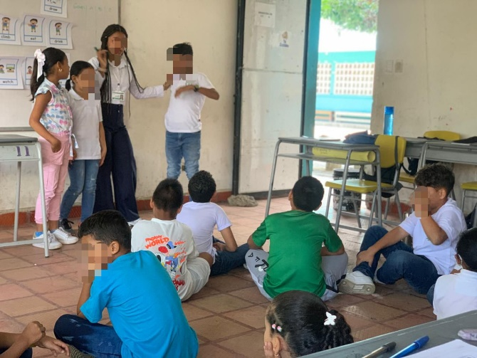 | Match the Image with the Word  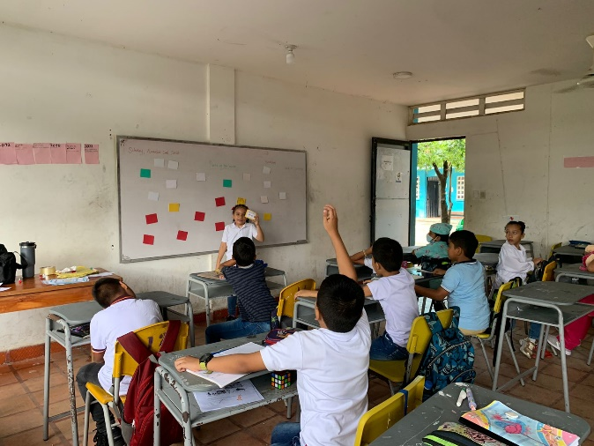

Task-Based Language Learning
Comic Strip Related to Peaceful Education  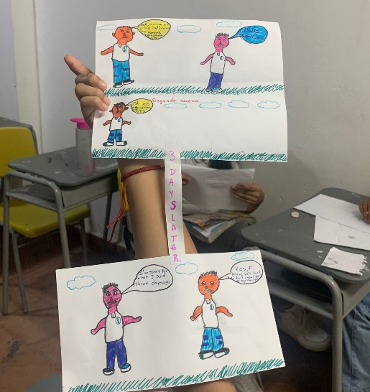 | Eating Disorders Poster  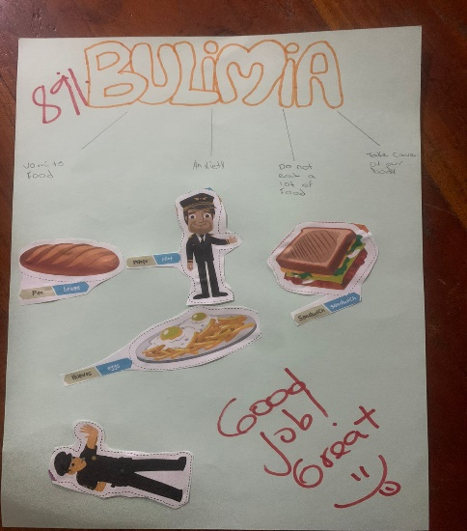

Recreational Activities
Professions’ Day  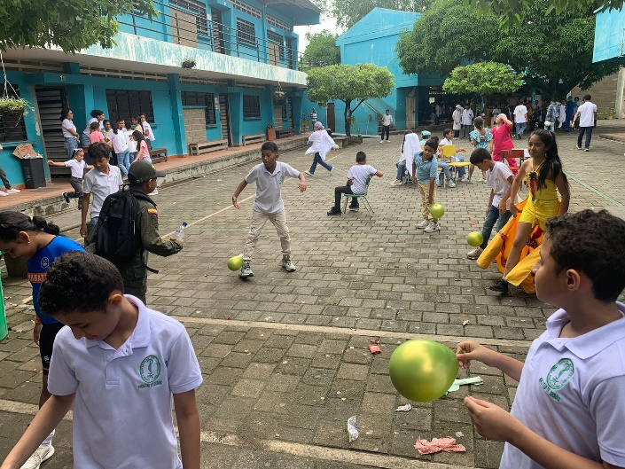 | Love and Friendship  